**ASSIGNMENT 5:**

**Module 6: Data Structures and Strings in Python**

**Task 1: Create a Dictionary of Student Marks**

**Problem Statement:** Write a Python program that:

1. Creates a dictionary where student names are keys and their marks are values.

2. Asks the user to input a student's name.

3. Retrieves and displays the corresponding marks.

4. If the student’s name is not found, display an appropriate message.

**Expected Output:**

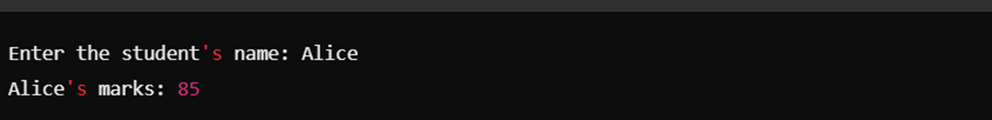

If the student does not exist in the dictionary:

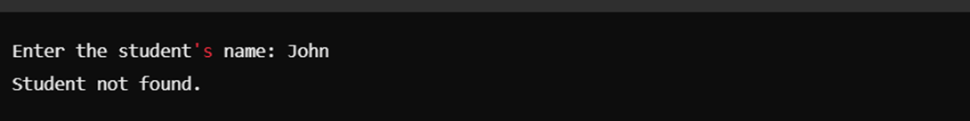

**Task 2: Demonstrate List Slicing**

**Problem Statement:** Write a Python program that:

1. Creates a **list** of numbers from **1 to 10**.

2. Extracts the **first five elements** from the list.

3. Reverses these extracted elements.

4. Prints both the extracted list and the reversed list

**Expected Output:  
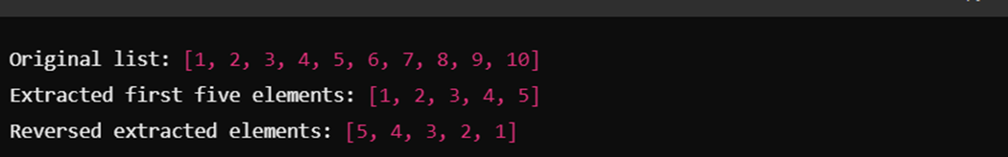**

**Submission Instructions:**

* Create a **GitHub repository** and upload your Python scripts (.py files).
* Ensure the repository includes a **README.md** file that describes the functionality of your programs.
* Add both **Task 1 and Task 2** scripts in the same repository.
* Submit the **link to your GitHub repository** once uploaded.

**Reference:**

Follow the **Python course - Module 6: Data Structures and Strings** for additional guidelines and examples.

**Note: Please test your project thoroughly and check all the validations and error handling prior to ensure it works as expected before submission.**

**You can always connect to the mentor using the chat support option for any doubts or queries.**